As Mark Twain said – “It's not the size of the dog in the fight, it's the size of the fight in the dog that matters”. Though making up one of the smallest UK sub-specialist societies, Limb Reconstruction surgeons can rightly be described as punching above their weight, taking on cases when often limb ablation is the only alternative. The BLRS AGM is one opportunity for “frame geeks” to network with likeminded colleagues, to consider newer techniques and to listen to pioneers in the field.
The 2015 AGM was hosted by Deepa Bose, Consultant Orthopaedic Surgeon at QEH, Birmingham. Deepa arranged a fantastic conference to address key issues around the practice of limb reconstruction within the NHS. In addition, it was another opportunity for the society to discuss the challenge of monitoring outcomes nationwide through the BLRS Registry and the debate was framed by a keynote address from Fergal Monsell (BLRS President Emeritus).
Birmingham boasts of particular expertise in combat trauma and this added a distinctive flavour to the meeting with talks from health professionals treating soldiers. There were insightful talks on managing pain in limb trauma reconstruction, the sequelae of blast injuries, amputation and prosthetics.
Dror Paley, Florida, USA, was a visiting speaker for the AGM. He enjoys a pre-eminence in the field of limb reconstruction and he shared his experience with intra-medullary lengthening and congenital limb deficiencies. There were many other memorable instructional lectures from other speakers on topics including Chronic Osteomyelitis and the use of plate fixation as an adjunct to distraction osteogenesis.
Deepa surpassed all previous hosts by arranging a solar eclipse on the 20th of March, the second day of the conference! A timely coffee break was arranged for delegates to view this rare celestial phenomenon. It added to a memorable meeting and will have whetted the appetite of many delegates to attend the next AGM to be held jointly with BAPRAS in Liverpool on the16th-18th March 2016.

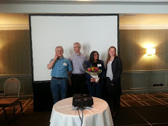
Fig 1: Deepa Bose and co-hosts

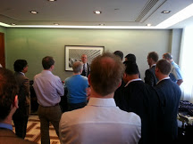

Fig 2: Dr Paley discussing techniques of lengthening at one of the workshops

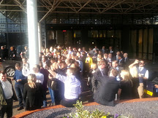

Fig 3: Bathed in Birmingham spring sunshine, delegates take in the solar eclipse.

